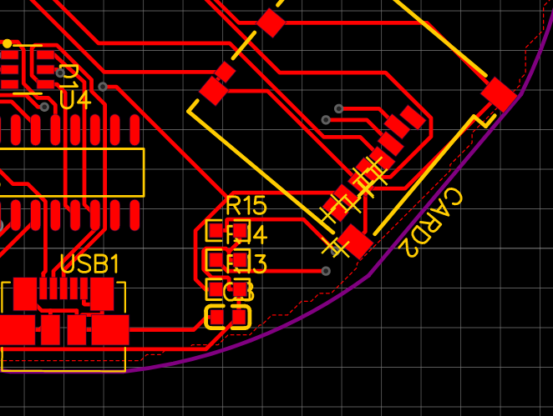

Front side (component side)

Cut here

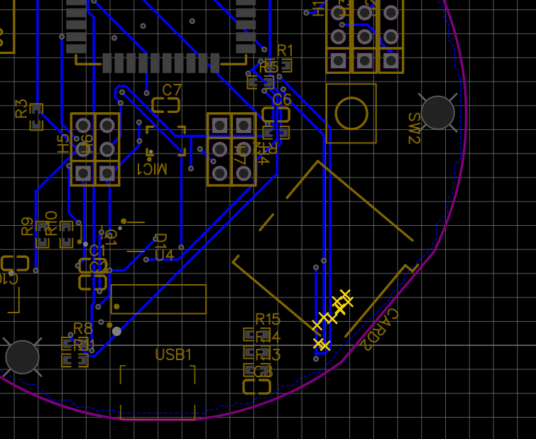

Back side

Cut here

Cut here

Add Jumpers (top side view)